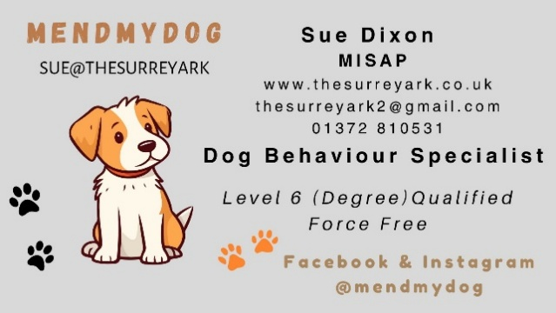
Dog Behaviour Basic Assessment
Questionnaire

Owner & Dog Information:
- Owner(s) Name:
- Veterinary Surgeon (if referred):
- Address:
- Postcode:
- Phone Number:
- Email Address:
- Dog’s Name:
- Breed:
- Sex: (M/F)
- Neutered? (Yes/No) - If Yes, at what age?
- Dog’s Age: (Years/Months)
- Age when obtained: (Years/Months)
- How would you describe your dog’s temperament?
- Have you owned a dog before? (Yes/No) If Yes, which breed(s)?

Early History
- Where did you get your dog from? (Breeder, rescue, private owner, etc.)
- How many previous owners has your dog had?
- Describe the previous environment(s) your dog has lived in: (e.g. family home, farm, kennel, with children, other pets, hand-reared)
- Did you meet one or both parents of your dog?
- Where did you meet the parents? (Family home, breeder’s facility, etc.)
- Did the mother interact with the puppies in a caring manner?
- If adopted from a rescue, how long was your dog there? What was the reason for rehoming?
- Why did you choose this breed or individual dog?

Health & Medical History
- Does your dog have any current or past health problems?
- When was your dog last checked for pain-related issues?
- Is your dog on any medication, herbal remedies, or supplements?
- Has your dog ever been bred? If yes, please provide details.
- Is your dog currently on medication for behavioural issues? If yes, list the medications and dosage.
- Have you noticed any changes in behaviour since starting medication?

Household & Routine
- List all household members (names, ages, and involvement with the dog):
- Who else is involved in the dog’s care? (Walkers, groomers, daycare, boarding facilities)
- Have they reported any issues?
- At what age did your dog start attending these services?
- List other household pets (species, breed, age, sex, neutered status, and date they joined the household):
- Describe the relationship between household pets:
Daily Routine:
- How long is your dog left alone on weekdays and weekends?
- Where does your dog stay when left alone?
- Does your dog bark or whine when left alone? (Yes/No)
- Does your dog do any of the following when left alone? (Check all that apply)
- [ ] Vocalise [ ] toilet inside [ ] engage in destructive behaviour [ ] eat [ ] play with
- Have you recorded your dog when alone? If yes, what did you observe?
- Where does your dog sleep at night?
- Does your dog wake you up at night?
- Does your dog have access to toys?
- Does your dog have access to a garden? If yes, when?
- Where does your dog go to the toilet?
- Does your dog urine-mark indoors?
- Does your dog follow a specific person around the house?
- Describe a typical 24-hour day for your dog:
- How does your dog behave during family meals?
- Have there been any recent changes in household routine (new job, baby, move, new people, diet change)? If yes, please describe.

Favourites & Diet
- List five things your dog enjoys most (foods, toys, activities):
- What brand/type of food is your dog fed?
- What treats does your dog receive and how often?
- How many times a day is your dog fed, and at what times?
- Are supplements included in your dog’s diet? If yes, describe:
- Where is your dog fed?
- Who feeds your dog?
- Does changing food affect behaviour?
- Does your dog show guarding behaviour around food? (Growling, looking anxious, etc.)

Exercise & Play
- How often and for how long is your dog walked?
- Equipment used (circle all that apply): Collar / Body Harness / Lead / Extending Lead / Head Collar / Muzzle
- Does your dog go off-lead? If not, why?
- Are games or toys included in exercise? If yes, what types?
- Who initiates play, you or your dog?
- Does your dog interact with other dogs?

Training & Behaviour Concerns
- Have you attended training classes or worked with a behaviourist?
- What advice was given?
- Did you receive a written behaviour plan?
- Were you happy with the advice?
- How old was your dog during training?
- What training methods were used (food rewards, corrections, etc.)?
- What training equipment was used?
- Does your dog:
  - Come when called? (Yes/No)
  - Drop objects when asked? (Yes/No)
  - Pull on the lead? (Yes/No)
  - Walk to heel? (Yes/No)
- What commands does your dog know?
- How do you correct your dog when they misbehave?
- Would you describe your dog’s learning ability as: (Good / Average / Poor)
- What tasks will your dog reliably perform on command? (Sit, Stay, Down, Fetch)
- Is your dog more obedient in certain situations or with specific people? If yes, describe.

Main Behaviour Concerns
- Describe the concerning behaviours in order of severity:

- When does this behaviour occur?

- Is it directed at a specific person?

- Who is usually present when it happens?

- What happens immediately before?

- How do you respond? How does your dog react to your response?

- Has there been any trauma or changes in circumstances?
- Has the behaviour increased in frequency or severity?

- Describe the most recent incident in detail:

Has your dog ever bitten a person or dog? If so please explain:

Final Questions
- Under what circumstances would you consider rehoming or euthanasia?
- What are your expectations for change?
- Are you committed to working on the issue?
- Is there anything else you’d like to share about your dog?
Signature: _________________________ Date: _______________
Thank you for completing this form! This will help us understand your dog’s behaviour and provide the best possible support.

